**P7 – Explain how polling and interrupts are used to allow communication between processor and peripherals**

**Introduction**

In this report, I will be explaining what are polling and interrupts. I will give examples of them and say how communication is allowed between these two.

**Polling**

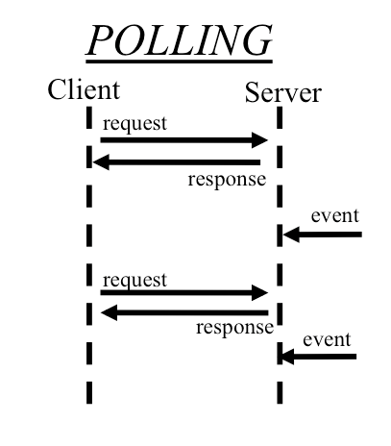Polling, in computer science, refers to the active status of an external device. This could be a printer. Polling comes in to play when the user keeps an eye on the input/output of what the user does. In other words, if the user prints of a document, polling will check the status of the printer to see everything is complete to be done. Once the status has been checked, the printing can now begin. This is very important for any task to be complete, because if the communication is not allowed, the user cannot complete easy tasks e.g. print out document. This alerts any danger to the user. For example, if paper is out of paper. Polling will check the status, and it will notify the user to put paper in. Once this is complete, the process would begin.

**Interrupts**

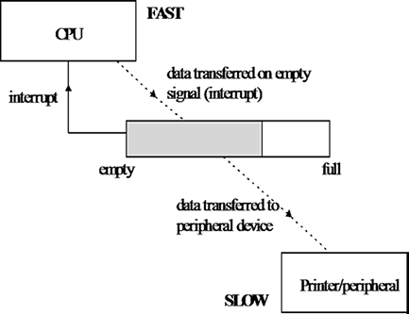This plays an important part between the two. This gives a signal to the processor indicating that a hardware or software needs to be paid attention. This is very important for any computer. They are many advantages of having this system, because the processor can fix any device that needs to be paid attention. For example, if a software has an error and it needs to be dealt with, the interrupt would play a part and fix it. There is not only 1 interrupts, but there is more than one. However, there is a limited amount of them. If more than one needs to use this system, then the user sends out how many needs to be dealt with. However, if there is many, it should be dealt with one at a time.

**Peripherals**

Peripherals are devices that are attached to the computer which is controlled by the processor of the computer. This can be output or input device. Input devices are Camera, scanner, mouse keyboard. Output devices are monitor, printer. For example, a keyboard is attached to the computer for it to work. It’s attached to it, not built into it.

**Processor**

A processor is a microchip imbedded into the CPU’s hard drive that manages all the programmes. It is known as the, “brains of the computer”. The processor holds instructions, which is given to the programmers. They are different types of processors: INTEL and AMD. For example, INTEL has different types such as Intel i3, i5, i7. Intel i7 has four cores. The speed of this is 3.5GHz. The cache is 6MB. Obviously, each of the Intel processors named, they have different speed and cores. They have an electrical path that allows communicate between other components.

**How communication is allowed between the processor and peripheral?**

Communication can be established by each of the peripherals communicating with each other. Interrupts and Polling are used to communicate with other devices. They communicate with one another to solve a problem. It is not English, like we speak, but it is numbers (zeros and ones). This is called a bus. A bus, in computing terms, is referred to a set of wires that connects any independent components of the system, so that they can pass signals between them. Two of them could be processor and peripheral. There is not only one bus, they are many of them. Each of them has a different job. Some of them are data bus, address bus, control bus, and system bus.

**Reference**

<http://en.wikipedia.org/wiki/Polling_(computer_science)>

<http://ib-computing.net/images/SingleBuffer.gif>

<http://www.heise.de/developer/imgs/06/6/7/6/2/3/3/Polling-61cb54a128001c08.png>